Grace’s Go Kart Dash
VErsion 1.0

Table of Contents

Grace’s Go Kart Dash 0
Table of Contents 1
Section I - Game Overview 4
Game Concept 4
Genre 4
Target Audience 4
Game Flow Summary – How does the player move through the game? Both through framing interface and the game itself. 4
Look and Feel – What is the basic look and feel of the game? What is the visual style? 4
Project Scope – A summary of the scope of the game. 4
Number of locations 4
Number of levels 4
Section II - Gameplay and Mechanics 4
Gameplay 4
Objectives – What are the objectives of the game? 4
Mechanics – What are the rules to the game, both implicit and explicit. This is the model of the universe that the game works under. Think of it as a simulation of a world, how do all the pieces interact? This actually can be a very large section. 5
Physics – How does the physical universe work? 5
Movement 5
Screen Flow 5
Screen Descriptions – What is the purpose of each screen? 5
Section III – Story, Setting and Character 6
Story and Narrative - Specific details like scripts and cut scenes may not be in this document but be in the Story Bible. 6
Back story 6
Game Progression 6
Cut Scenes 6
Game World 6
General look and feel of world 6
Area #1 6
Area #2, 3, and 4 6
Area # 5, 6 6
Characters 7
Character #1 7
Section IV – Levels 7
Level #1, 2, 3 7
Synopsis: 7
Objectives: 7
Physical Description: 7
Level #4 7
Synopsis: 7
Objectives: 7
Physical Description: 7
Level #5 8
Synopsis: 8
Objectives: 8
Physical Description: 8
Section V - Interface 8
Visual System 8
Menus 8
Control System – How does the game player control the game? What are the specific commands? 8
Help System 8
Section VI – Technical – This may be abbreviated with most in the Technical Bible. 8
Target Hardware: 8
Development hardware and software: 8
Game Engine 9
Scripting Language 9
Section VII – Game Art - This may be abbreviated with most of the content in an Art Bible. 9
Concept Art 9
Style Guides 9
Characters 9
Environments 9
Equipment 9
Miscellaneous 9
Section VII - Management 9
Detailed Schedule: 9
Test Plan: 9
Section VIII - Appendices 9
Asset List 9
Art 9

Section I - Game Overview

Game Concept
The concept of Grace’s Go Kart Dash is to have a game which the kids can play after they visit Luton Museum and learn about the basics of gravity, force, and friction.

Genre
Educational Sports

Target Audience
The target audience is KS1 children (5-7 yrs old)

Game Flow Summary – How does the player move through the game? Both through framing interface and the game itself.

Look and Feel – What is the basic look and feel of the game? What is the visual style?
The visual style of the game is a cartoon, hand drawn kind of look.

Project Scope – A summary of the scope of the game.

Number of locations
There are 2 general locations. One is in the forest and the other is in Luton town.

Number of levels
There are 5 levels in the game.

Section II - Gameplay and Mechanics

Gameplay

Objectives – What are the objectives of the game?
The objective of the game is to get Grace to Luton in the fastest time as possible.

Mechanics – What are the rules to the game, both implicit and explicit. This is the model of the universe that the game works under. Think of it as a simulation of a world, how do all the pieces interact? This actually can be a very large section.

Physics – How does the physical universe work?
The physics are emulated by code from www.coreyoneil.com (https://code.google.com/p/collisiondetectionkit/)

Movement
Movement is controlled by 3 keys- left arrow, right arrow and spacebar. Pressing left arrow drives the kart back. Pressing right arrow drives the kart forwards. Pressing the spacebar activates the breaks of the kart.

Screen Flow:
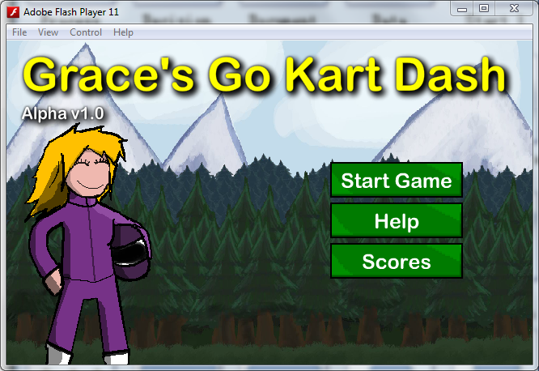
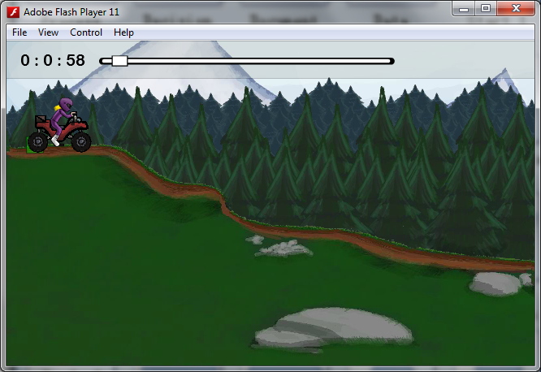
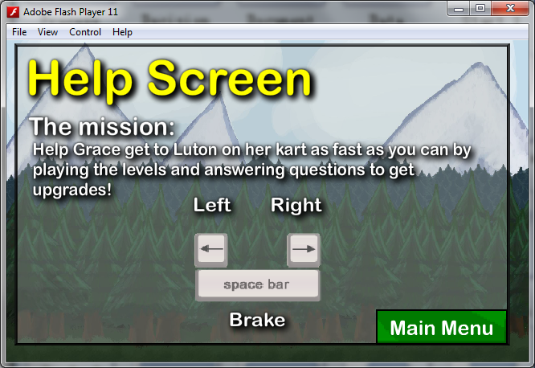
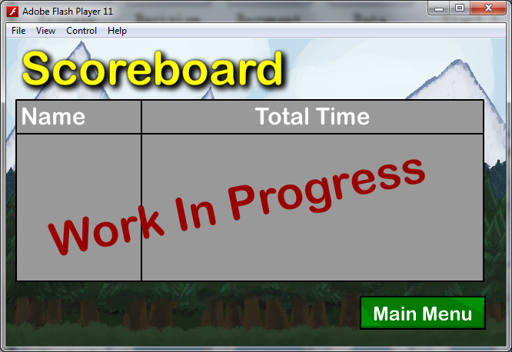

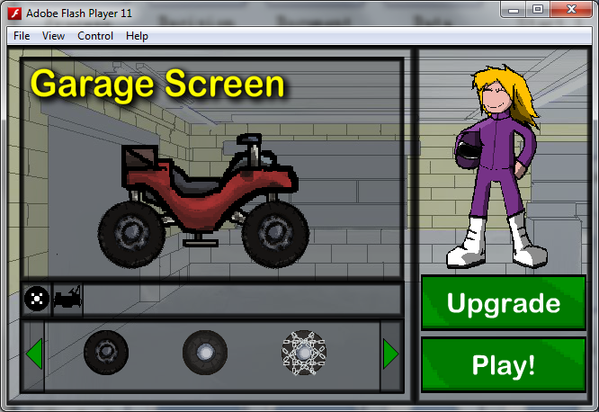
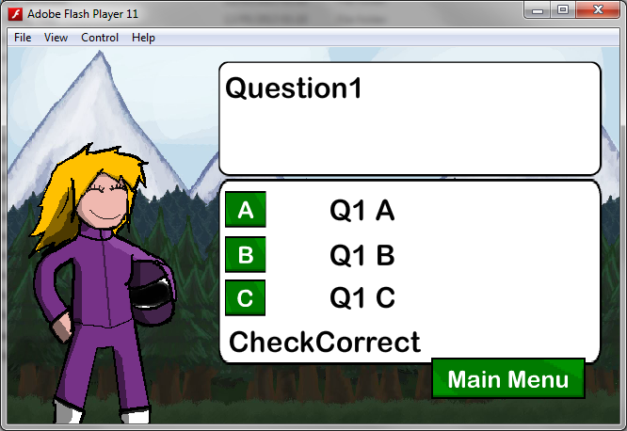
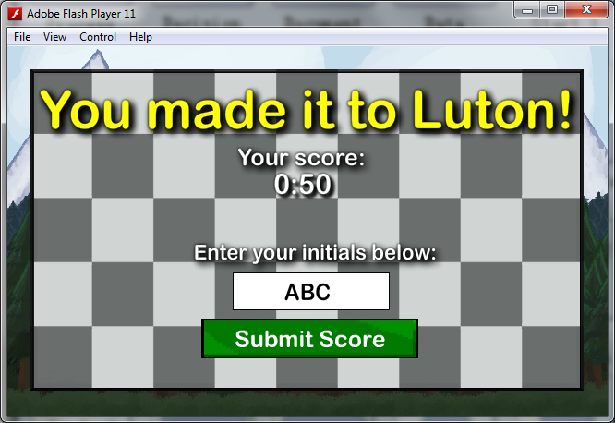

Screen Descriptions – What is the purpose of each screen?
- Main Menu Screen
- The purpose of the Main Menu Screen is to provide the user with a menu to get to the Level Screen, Help Screen, and Scoreboard Button.
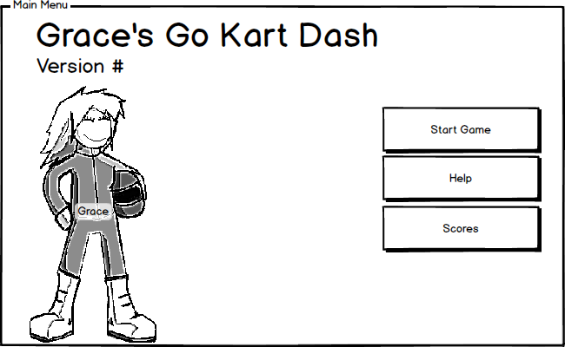
- Help Screen
- The purpose of the Help Screen is to provide the user with some backstory and controls.
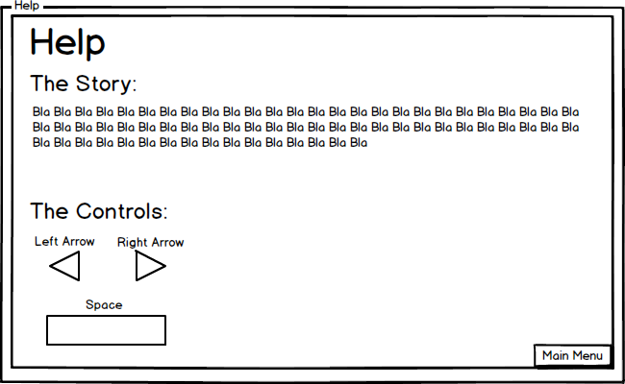

- Level Screen
- The purpose of the Level Screen is so that the user can play the game.
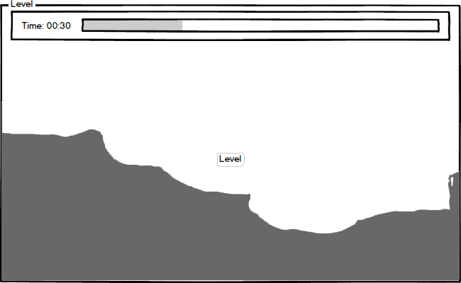
- Garage Screen

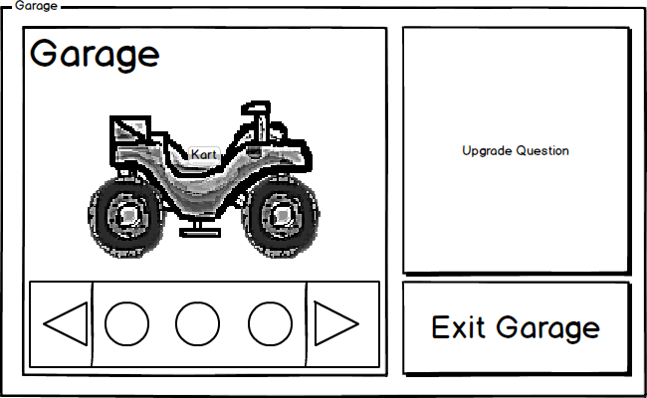
-The purpose of the Garage Screen is so the user can customize the kart so he/she can beat the game faster.

- Question Screen
-The purpose of the Question Screen is to educate the user as well as reward the user with an upgrade to Grace’s kart.
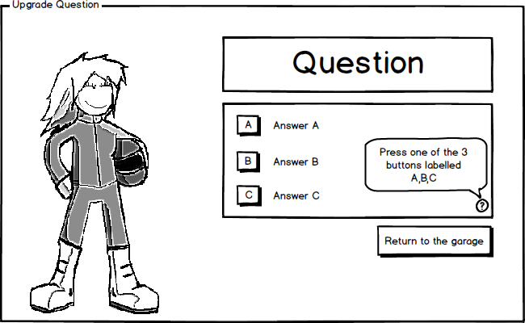
- End Game Screen
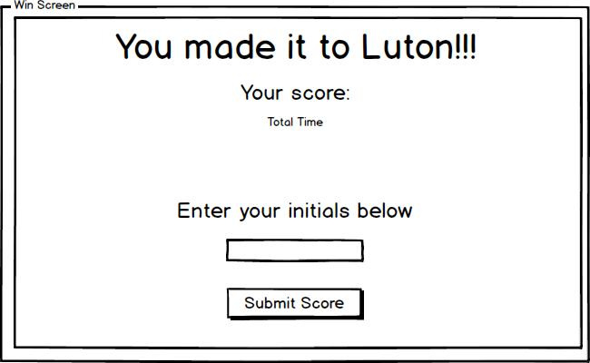
-The purpose of the End Game Screen is to provide the user with their total time and also add their time to the scoreboard
- Scoreboard Screen
-The purpose of the Scoreboard screen is to provide the user with the times of other players.

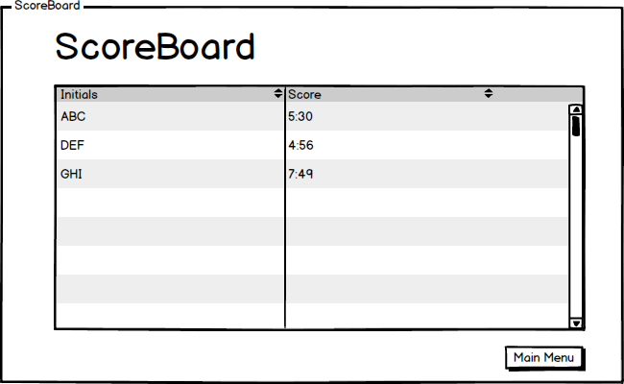
Section III – Story, Setting and Character

Story and Narrative - Specific details like scripts and cut scenes may not be in this document but be in the Story Bible.

Back story
The backstory is that Grace has a wooden soapbox kart but she needs to get to Luton town.

Game Progression
The game progresses like this. The player completes a level and they enter the garage. After they customize their kart for a faster driving experience, they go out again to the next level…and so on until they reach the final garage in Luton town.

Cut Scenes
Cut scene #1
Actors: Grace
Description: This is the first think the player sees when playing the game. Grace rolls in on a wooden soap box kart and she doesn’t have enough power to get all the way to the garage. Therefore the user must answer a question to get her out of the kart and push the kart to the garage for an upgrade.

Game World

General look and feel of world

Area #1
Area 1 is the cut scene at the beginning of the game. It is in the forest. It is connected to the other areas as the objective of the game is to get Grace out of the forest and into Luton town

Area #2, 3, and 4
Area 2-4 are also in the forest/countryside. As grace gets closer to the city she gets further away from the mountains (seen in the background).

Area # 5, 6
Area 5 and 6 are in Luton Town. By now Grace has travelled for a long time so it has snowed a bit in area 5. In area 6 however it is nice and sunny and grace is traversing the city rooftops.

Characters

Character #1
- Physical characteristics
- Grace has a purple motorbike suit with white boots on and a blonde pony tail
- Animations
-Grace has 2 sets of animations. One is for the kart- when she is on the ground she is sitting on the kart but when she’s in the air she is standing on the kart’s foot platforms. The other set is a walking animation when she’s pushing the wooden soapbox along the grass

Section IV – Levels

Level #1, 2, 3

Synopsis:
This is the first, second, and third level you play after you enter the garage in the introduction scene

Objectives:
The objective for all of the levels is get to the next garage and upgrade your kart.

Physical Description:
It is in a green forest. There are tall, snowcapped mountains in the background. There are trees as far as the eye can see. This is the description of the first 3 levels. They only differ in the ground underneath Grace

Level #4

Synopsis:
This is the fourth level you play in the game

Objectives:
The objective for all of the levels is get to the next garage and upgrade your kart.

Physical Description:
It is in a snowy part of Luton. You can see the Wardown Park Museum at the beginning of the level and a silhouette of buildings behind it.

Level #5

Synopsis:
This is the fifth level you play in the game

Objectives:
The objectives for all of the levels is get to the next garage and upgrade your kart.

Physical Description:
It is in a snowy part of Luton. You can see the Wardown Park Museum at the beginning of the level and a silhouette of buildings behind it.

Section V - Interface

Visual System
The game can be viewed on a computer monitor with a resolution of 800x600 or more.

Menus
There is currently only one menu system at the moment and that is in the main menu screen. Other than that there are stray buttons around the other screens which link them with one another.

Control System – How does the game player control the game? What are the specific commands?
The player controls the game by pressing the left, right, and spacebar. Pressing left drives the kart back. Pressing right drives the kart forwards. Pressing spacebar activates the kart’s breaks.

Help System
There is a help screen which is accessible from the main menu screen. It is also shown before the first level is played.

Section VI – Technical – This may be abbreviated with most in the Technical Bible.

Target Hardware:
The target hardware is any modern day computer with an average internet connection speed. The computer will also need to have an Adobe Flash enabled internet browser.

Development hardware and software:
The development hardware was a Dell desktop with an Intel Xeon and Nvidia Quadro 600 running Windows 7.

Game Engine:
Adobe Flash CS5/CS6

Scripting Language
AS3

Section VII – Game Art - This may be abbreviated with most of the content in an Art Bible.

Concept Art :

Style Guides

Characters

Environments

Equipment

Miscellaneous

Section VII - Management

Detailed Schedule:
Throughout the development process we always contacted through Skype. Russ has work on Tuesdays to Sundays until about 6. Therefore we discuss issues or ideas after that hour or in university on Wednesdays and Fridays.

Test Plan:

Section VIII - Appendices

Asset List

Art
Model and Texture List
Animation List
Effects List
Interface Art List

